Fifth Asian Workshop on Foundations of Software（AWFS 2007）
Registration, Lodging, and Travel Information

- Workshop Location：Software School, Xiamen University
The Software School of Xiamen University, founded in February 2002, is one of the 35 national exemplary software schools approved by the Chinese Ministry of Education. It is managed by the Dean under the governance of a board of directors. The School lodges the Software Research and Development Center of Xiamen University and has several practice bases in and out of the University that provide advanced software and system platforms to support the research and development activities of teachers and students. For detailed information about the Software School, please visit: http://software.xmu.edu.cn
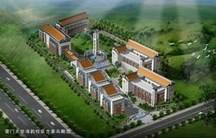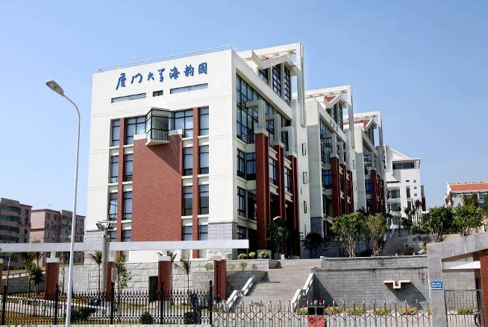

- Travel Information
Travel to Wuyi Mountain (http://www.wuyimountain.com/): departure from Xiamen by train on June 3 evening and return to Xiamen on June 5 later evening. Participants are responsible for their own travel expenses.
Other travel information: http://www.xmtravel.com.cn/

- Contact Information
Zhiling Hong
Software School of Xiamen University
Phone: +86 -13515967879
Fax: +86-592-2580500
Post Code: 361005
E-mail: xmudbase@xmu.edu.cn

Yanfang Ye
Software School of Xiamen University
Phone: +86 - 592 -6810670
Fax: +86-592-2580500
Post Code: 361005
E-mail: yeyanfang@yahoo.com.cn


- Workshop Hotel

Lujiang Harbourview Hotel offers the following corporation contract rates, subject to the terms and conditions set out in this contract:

Room Type | Contract Rate（RMB） | Contract Rate（USD）
Standard room with double bed | RMB 420 | USD 55
Deluxe standard single room | RMB 490 | USD 64
Suite room | RMB 510 | USD 66
Deluxe suite room | RMB 575 | USD 75
Single room | RMB 375 | USD 49

Guests will enjoy the following special treatments:
- Daily complimentary breakfast
- Free use of Broad Internet Access in room
- 2 complimentary bottles of mineral water
- Daily newspaper
- Free use of the Fitness Centre
- 10% discount on restaurant

Remarks
- Extra bed is chargeable at RMB 150 net (includes breakfast). Breakfast will be chargeable at RMB 50 net per person, for the visitors.
- The above corporate rates are inclusive of 15% service charge and 4% government tax.
- All the above quoted corporate rates are not available during the CIFIT (6th/Sept-10th/Sept) and the public holidays, such as: Lunar Chinese New Year (Spring Festival)/Labor Holiday/National Holiday/New Year Holiday.
- The hotel reserves the right to release the room at 18:00 on the day of arrival if the booking is not guaranteed.

54 Lujiang Road, Xianmen 361001,Fujian Province, P. R. China Tel: 0592-2022922 Fax: 0592-2024644
E-mail: lujihtl@public.xm.fj.cn Website: www.lujiang-hotel.com

5. Workshop Registration

(1) Registration fees (US$):
Registration date | Regular registration fee | Student registration fee | Registration fee for accompanying person
Before May 31, 2007 | 180 $ | 90 $ | 60 $
The registration fees cover workshop proceedings, tea breaks, meals (including the banquet), and in-city excursion. Hotel costs and the expenses of travel to Wuyi Mountain are not covered. Students should provide proof of student status at the time of registration.

(2) Payment: Pay with cash on the workshop site.

(2) Registration: Please fill in the registration form below and send it to the following e-mail address:
xmudbase@xmu.edu.cn
Registration Form for the Fifth Asian Workshop on Foundations of Software

1. Information about participant(s)
Name | Title of post ¹ | Sex | Paper number ² | Accompanying person | Sex
Organization：
Mailing address（Post Code）：
Telephone（Area Code）: Fax：
E-mail：
Contact person： Cell phone：

2. Hotel Reservation
Date and time of  arrival: | Arrival: ( ) By bus By train  By air |  | Need pick up at the railway station or airport: Yes  No  If yes, train or flight number:
Hotel reservation :  Yes  No |  | Arrival date: | Departure date:
Room type |  | Number of rooms | Shared with other participants
 |  |  | Yes  No
 |  |  | Yes  No
Special Request: No  Yes___________________________________
Remarks:
3. Return Ticket Reservation
Return Time: (MM/DD/YY) Xiamen To  Air Ticket  Railway Ticket (No.) (Berth Ticket Seat Ticket)
Scheduled Flight /Train： First Choice Second Choice
Remarks:

4.Travel Reservation
Travel to Wuyi Mountain (June 4 and 5):  Yes  No

1 Indicate if the participant is a student
2 Indicate if the paper is invited

